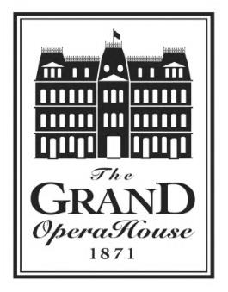
The Grand Rental Event Questionnaire

This application is intended to provide initial information of the needs of potential clients of The Grand Opera House. This questionnaire must be submitted for your rental to be considered. Your date and event will be confirmed once an invoice has been agreed upon and a contract has been made, signed and returned.

Questions?
Contact Jessica Lewis
302-658-7897 ext: 3405
jlewis@grandopera.org

Renter Information
Event Name: __________________________________________________________________
Requested Event Date: ____________________
Primary Contact: ______________________________________________________________
Company/Organization: ________________________________________________________
Address: _______________________________________
_______________________________________
Primary Phone: _________________________ Secondary Phone: ______________________
E-mail: _______________________________________________________________________
Requested venue/facility: (Please check all that apply)
☐Sarah Bernhardt Salon ☐baby grand Lobby ☐Wesler Room
☐Studio 1 ☐Ninth Muse ☐baby grand Stage
☐Copeland Hall Stage

Have you ever utilized any of our venues before? ☐Yes, when? ________________ ☐No
Are you a non-profit organization? (Proof of 501c3 will be needed) ☐Yes ☐No
How did you hear about us? (Please check all that apply)
☐Attended a previous event ☐Attended a performance ☐Web search
☐Word of mouth ☐Referral
☐Other ______________________________________________________________________
Event Information
Please describe your event in detail (please include expected number of guests):
__________________________________________________________________________________________________________________________________________________________________________________________________________________________________________
Preliminary Timeline
What time will the first person from your event arrive for setup? __________________

What time will your event begin? __________________

What time will your event conclude? __________________

What time will the last person exit the facility? (Must be by 11pm) __________________

Will you have catering? __________________
(All catering MUST be through The Grand’s preferred catering list)

Beverages
*NO outside beverages are permitted in the building. Everything must come from The Grand stock*
What beverages would you like available to your guests at NO COST TO THEM?
☐Coffee ☐Tea ☐Juice ☐Water
☐Soda ☐Beer ☐Wine ☐Liquor
Would you like regular or premium alcohol? ☐Regular ☐Premium
Would you like to have a cash bar on certain items? (Please circle) YES or NO
If so, what would you like offered at the cash bar? (Please specify regular or premium)
______________________________________________________________________________

Upgrades
Would you be interested in any of the following event upgrades? (Please check all that apply)

☐ Up-Lighting Package - $150.00 (illuminate your event space in a color of your choosing)
☐ The Grand Façade - $100.00 (illuminate the façade of The Grand in a color of your choosing. *Availability may vary*)
☐Grand Kiosk Poster - $35.00 (The Grand will print and hang a kiosk poster that you design on the day of your event. Image must be a 15” x 25” PDF document and must be submitted to The Grand at least 2 weeks prior to your event – please do not use cell phone photos. *Availability may vary*)

